St Thomas Medical Group

St Thomas

Exwick

Exeter University Student Health Centre

Patient Participation Group (PPG)
Minutes of
Meeting 17th January 2024

Practice staff in attendance:
Nina Smith – Deputy Practice Manager and PPG Coordinator
Rillian Grant – IT Lead

Attended by 6 patients.

Introduction by Nina Smith

Presentation by Nina Smith

Review of actions from previous minutes

- Reminder Texts – Patients were receiving messages despite having had the flu vaccination. Our investigation suggested that this was occurring when the patient’s number was on a family members record. We will be reviewing this process for the 2024 flu season.
- New Website – Rillian joined us to discuss the new website and to arrange further patient input.
- Linking in with other PPG’s – Still to arrange.
- Waiting room TVs – We are still keen to set these up, but due to some technical difficulties this is taking longer than planned.
- Calendar of meetings – Dates circulated on the agenda.

COVID/Flu Clinic
- We have now completed the COVID/Flu programme for 2023.
- 5300+ patients were vaccinated against COVID.
- 7500+ patients were vaccinated against flu.
- The joint COVID/flu clinics proved very successful, with over 4400 patients receiving both vaccinations on the same day.
- Spring Booster – We do not know yet whether there will be a spring booster this year.

NHS App update & ambassadors

NHS App
The NHS App will be updated with a new home page, simpler structure and easier to understand language. For more information about the changes and for planned updates, please visit: NHS App and your NHS account - NHS (www.nhs.uk)

The COVID pass has now been removed from the app.

NHS Ambassadors
The idea is that NHS Ambassadors work across the NHS and will be proactive in carrying out a range of activities promoting the app, including via social media, face-to-face sessions etc. We have emailed out a request to our admin teams to ask for volunteers as we see this as a huge benefit to our patients, especially as the NHS app is evolving and being more widely used.

Pharmacy First

The new Pharmacy First service launches on Wednesday 31st January 2024. Patients can now seek advice from a pharmacy for the following conditions:

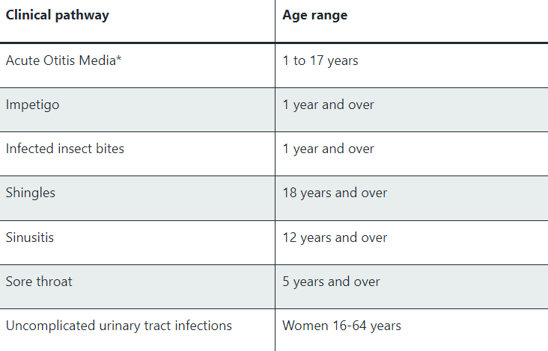

Pharmacies will continue to offer blood pressure checks and oral contraception services.
GP Practices and 111 will be able to refer into this service.

Practice Website

Rillian gave us an overview of the new website, presenting the look and feel and what it will offer patients. Feedback was gathered on the current layout and Rillian is keen to involve patients further in the design of the website.

Group Discussion

We spoke about the impact the new housing developments might have on the practice. These new developments currently fall in the catchment area for Exminster, Topsham and Ide, we are not anticipating any effect on our current patient numbers.

I was asked about our appointment books and the availability of appointments. I explained that we were within the national average in terms of booking appointments. I would be happy to provide some figures at our next PPG meeting in April.

Any other business?

A member of the PPG offered to reach out to some of the local PPGs.

A member of the PPG successfully tweaked the calendar of awareness campaigns so that it is displayed on one page – I will attach this to the email.
Actions

On-going development of new practice website – STMG & PPG Representatives
Promotion of awareness campaigns – STMG
Linking with other PPGs – STMG & PPG Representatives
NHS Ambassadors within the practice - STMG

Proposed meetings for 2024

Wednesday 17th April 2024
Wednesday 17th July 2024
Wednesday 16th October 2024

