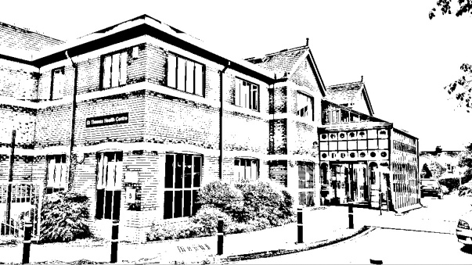
St Thomas Medical Group

St Thomas

Exwick

Exeter University Student Health Centre

Patient Participation Group (PPG)
Minutes of
Meeting 16th October 2023

Practice staff in attendance:
Dr Emma Green – GP Partner
Nina Smith – Operations Manager and PPG Coordinator

Attended by 4 patients.

Introduction by Nina Smith

Presentation by Nina Smith

Review of actions from previous minutes
- Encourage patients to approach the surgery with concerns or suggestions – We are still issuing our Friends and Family surveys and reviewing and responding to the comments/suggestions where possible.
- Promotion of ‘Awareness Weeks’ – On-going
- Review deposit for Blood Pressure Machines – This has been raised to £15.
- Calendar of meetings – Future dates proposed, happy to discuss alternative days.
- Drop-in session for NHS App support – Currently on hold until the vaccination programmes are completed.

COVID/Flu Clinic
- We enabled self-booking for COVID/Flu vaccinations, over 2000 patients used this feature which meant fewer calls into the practice.
- As of the 9th October, we have administered:
  - 4540 COVID vaccinations
  - 5646 Flu vaccinations
- We have now opened up COVID appointments to the National Booking Service.

Car Parking at St Thomas Health Centre
- We listened to the feedback from our patients about the car parking at St Thomas Health Centre.
  - On 1st September we implemented a change to our staff car parking policy.
  - Staff are now being asked to only park onsite for 50% of their working week.
    - Some colleagues have arranged to use a car park space at the local social club, more are cycling, car-sharing or using local roads.
  - We are aware of the current local resident parking consultation and will review our policy if necessary.
- We explained that this policy did not apply to doctors as they are required to work cross-sites and complete home visits.

Awareness Campaigns
- Calendar of upcoming awareness campaigns shared.
- PPG members would like to see the dates on the calendar.
- Our IT team have a list of upcoming campaigns so that information can be posted to our website and social media.
- We are moving to a new website provider so there will be a more functional dedicated PPG page with information about health awareness.
- We are adding information to the waiting room noticeboards.
- Look at targeting World Diabetes Day in November. Order/print resources.

Group Discussion
Reminder Texts
One PPG member mentioned that despite having had the COVID and flu vaccinations, they continued to receive reminder texts.

New Website
Discussion about new website provider. We are still in the early stages of the migration. However, we are going to start looking at the content of our website. We discussed the value of having some patient input into the development of the website and how this is viewed from a patient perspective. 2 members were keen to offer support us with this.

Linking in with other PPGs
We discussed visiting some other local PPGs which we know are well attended, to see how these are organised.
Would Chris be able to email the PM group to see who has a successful PPG and would they be willing for us to attend to see what we can learn from them?
Emma is aware that Barnfield Hill, Lyme Bay Medical Centre and Sidmouth Medical Centre have well established PPGs.

Waiting room TVs
Could more use be made of these, can we display information about the various awareness campaigns and updates about the practice.

Future meetings
Mondays are a little difficult for some members to attend. We have therefore decided to change the day of the meeting to a Wednesday and the proposed meeting dates will be updated to reflect this change.

Actions for next meeting
Calendar of meetings – Please see dates below – STMG
Formation of steering group for Website development – STMG
Print out/order resources for World Diabetes Day – STMG
Setting up of TVs in waiting rooms – STMG
Reminder Texts - STMG

Proposed meetings for 2024

Wednesday 17th January 2024
Wednesday 17th April 2024
Wednesday 17th July 2024
Wednesday 16th October 2024

